Video: Chivalry in the Middle Ages
- Chivalry is associated with a _________________’s code of conduct.
- Over time, it became associated with the morals and behaviors of the _______________ classes
- Chivalry values included: loyalty, _________________________, protection of the weak.
- The code of honor provided a way for aristocrats to move up the ________________ ____________

Video: Medieval Europe: Feudalism
- The Medieval way of life was based on the ownership of ___________________
- Under the feudal system, people of __________________ classes showed their respect to the upper classes by __________________________ them and for their service, they received rewards.
  - A king would sometimes reward a _______________ with a ____________________, an important unit of territory (land) in feudal society.
  - A __________________ came with land, a large house, several farms, a village, and all the _________________ who lived in the village. The crops on these lands provided the lord with his income. More manors = more riches
- The __________________ were at the bottom of the feudal society. They did not own land. They were bound to the land. This means they had to stay with the land and couldn’t move away or be sold to another manor.
  - The ____________ rewards the serfs for their labor by giving them a place to live, some crops, and protection.
  - Serfs had few ___________________ and no opportunities for education.
  - It was nearly impossible for them to get out of their poverty.
- The _______________________ were valued for military skills. They were professional warriors who usually fought on ____________________________. They came from wealthy families.
  - Knights held a high position in feudal society.
  - A noble lord would often reward a knight for his courage with gifts of _____________________

Video: Khan Academy: Charlemagne: An Introduction
- Between the ancient Roman Empire and Napoleon’s Empire, there was really only one ruler that controlled most of Western Europe: ____________________ or Charles the Great or Carolus Magnus.
  - On Christmas day in the year _______ exactly, Charlemagne is crowned emperor by the pope.
  - Constantine moved the Roman Empire to Constantinople, what is now Istanbul.
- The Western Roman Empire basically fell apart. We see the dissolution of the institutions of the Roman Empire. The idea of the Roman Empire hangs on but its ability to govern comes apart.
  - There was a series of ____________ of people moving into the Roman Empire. People like the Visigoths and the Huns. One of those peoples was the Franks. The Franks actually settled in what is now Germany and France. Charlemagne was a _____________.
- By Papal States, the video means the areas governed by the pope. Today, we think of the Pope as a spiritual leader, but back in the ninth century the pope was also a _________________ leader.
  - By the time the Lombards in northern Italy were threating Rome (and the Pope), the pope looked north to the kingdom of the Franks.
  - Charlemagne was called upon early in his career by the pope to protect the pope and the papal lands. Charlemagne became king of the Lombards.
  - The pope is getting ______________ __________________ and at the same time he’s offering a kind of legitimacy to the pope.
  - But what ends up happening is you have to very powerful figures in Western Europe (Charlemagne and the pope) and there will be a contest between these two offices.
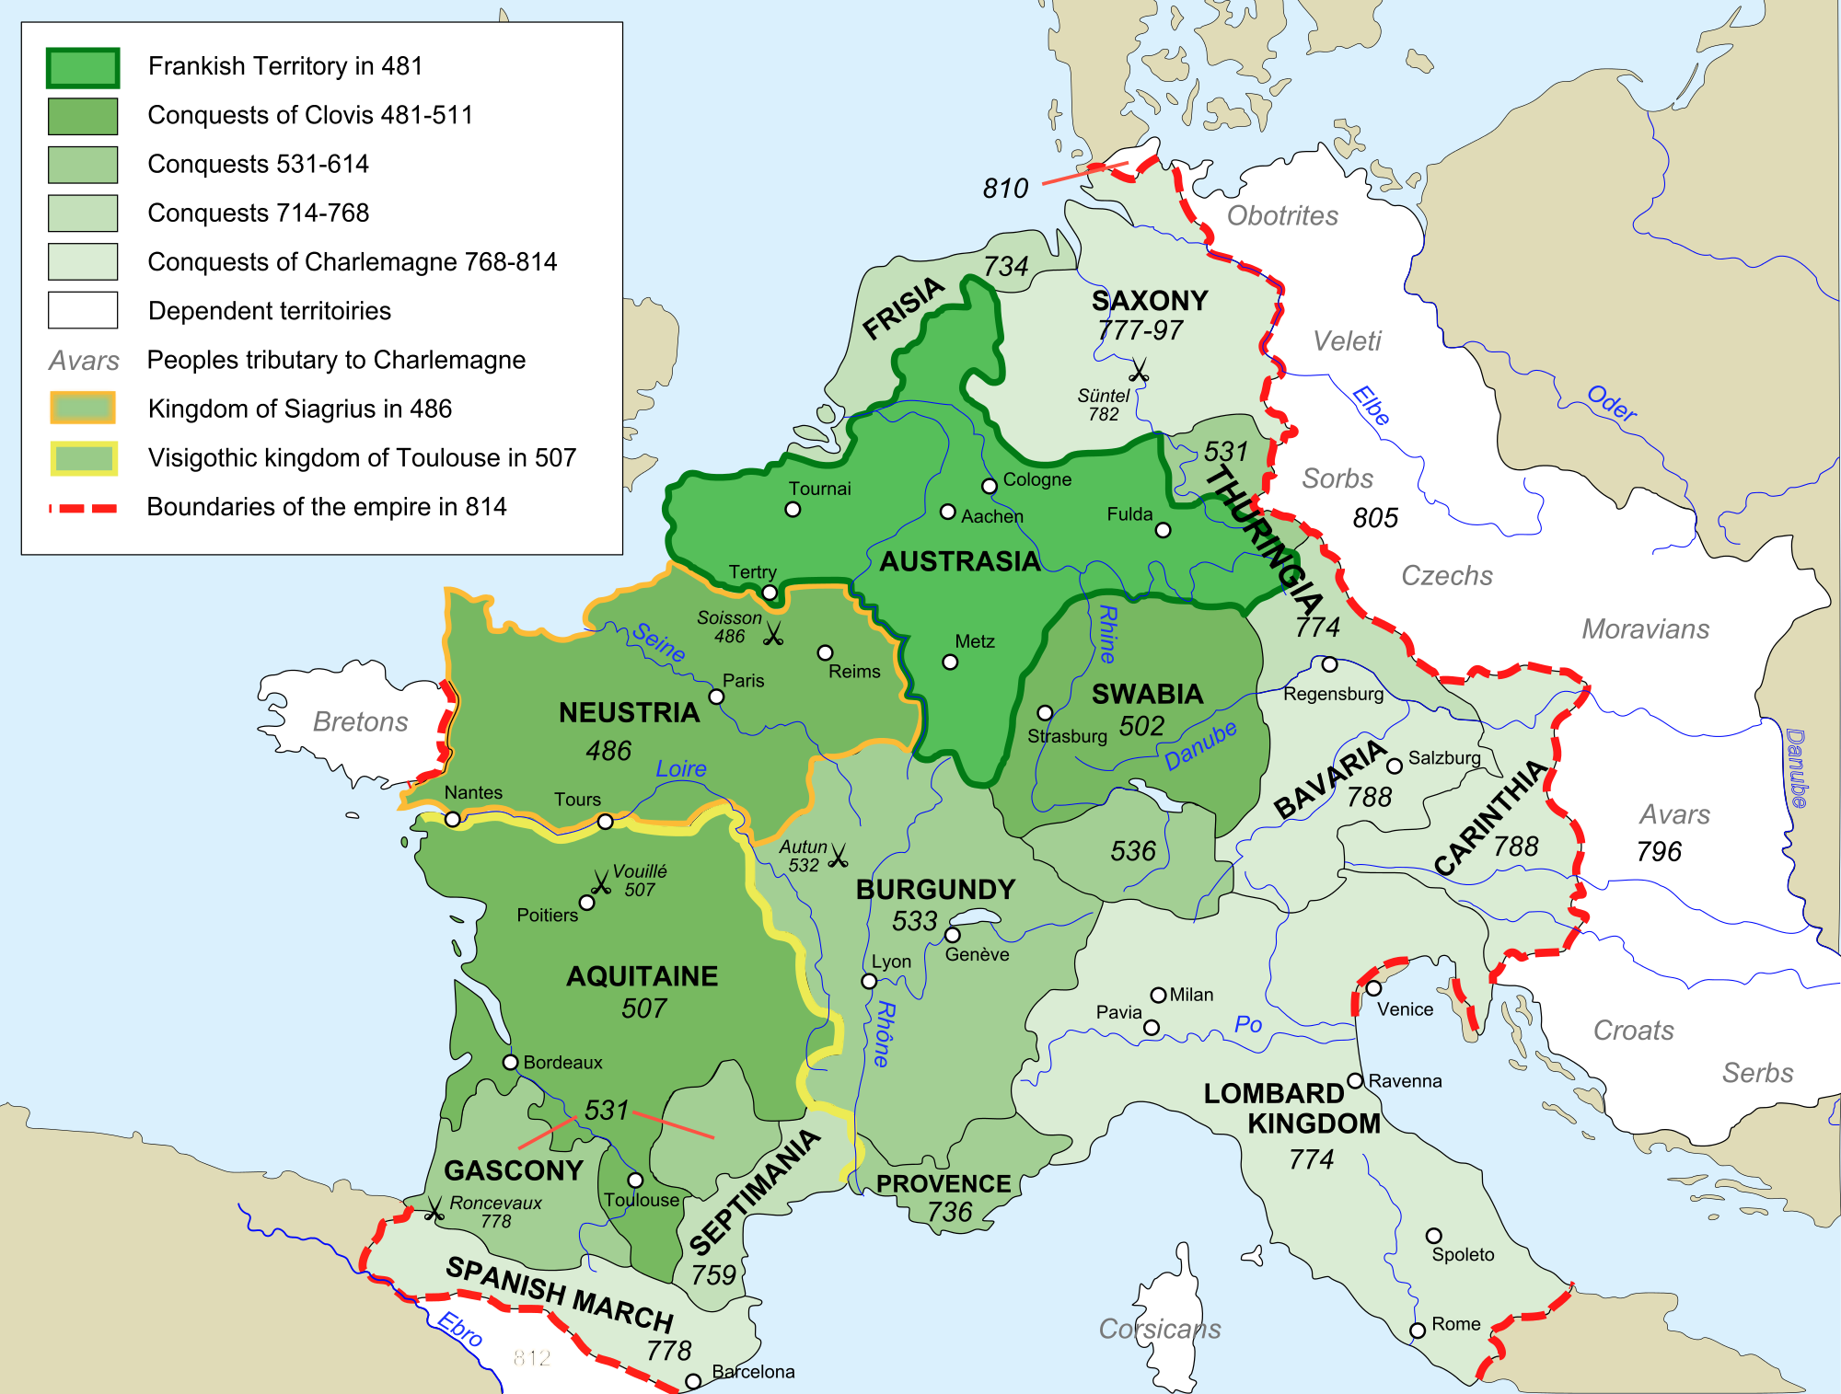
- There is the ________________ Empire in the East, the Pope ruling from Rome over the papal states in central Italy, and Charlemagne, who’s king of the Franks (France, Germany, northern Italy).
- Surrounding Western Europe in northern Africa, Spain, and the east is ________which was advancing quickly.
- In 799, the Pope was ___________ III and some Italians wanted him removed as pope. They went to Charlemagne who had the real power in Western Europe. Charlemagne meets with Pope Leo III and reestablishes his legitimacy as pope.
  - Pope Leo III crowned Charlemagne _______________ in 800. Now the capital of the Empire was not in Rome but in Aachen (present day __________________).
- ______________________ refers to the reign of Charlemagne and his successors. The west now had a Christian Emperor who was establishing a Christian Empire.

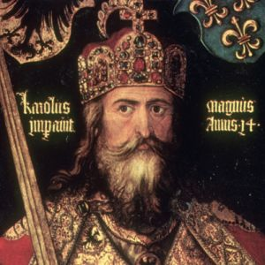
Video: Khan Academy: Charlemagne and the Carolingian Revival
- The question mark is Carolingian. It comes from about 800. We use the term Carolingian to refer to the time of Charlemagne and his successors.
- By the time we get to about 800, Charlemagne is ruling a vast amount of ______________________.
- Charlemagne needed to organize and _________ to create a Christian kingdom.
  - The Romans had law, they had roads, they had trade systems, the Romans had educational systems. This was ______________ by Charlemagne’s time.
  - Charlemagne needed to build these up again so his empire would function.
- Charlemagne was also deeply _________________. He took his Catholic faith seriously and that became the binding agent for all his people and lands. Charlemagne wanted to rule over a ______________________ kingdom.
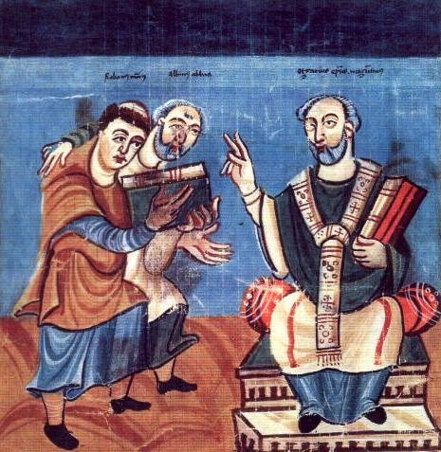
- Most of his priests were illiterate. Charlemagne needed to ________________ them so they could expose his kingdom’s population to Catholicism. Charlemagne creates schools to educate his __________________.
- Charlemagne created the political ___________________ and the wealth that allowed him to begin to institute a rigorous educational system for the clergy so they could read the __________________.
  - _______________ was the language of the government and the church—the two central authorities.
- Charlemagne set up scriptoriums; places were monks could _________________ books. There is a dramatic increase in manuscripts produced during the Carolingian Renaissance.
  - Charlemagne was interested in standardizing _______________ so that more people could read it and more monks could copy it.

