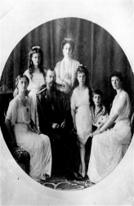
- The leader of Russia was Czar (the Russian word for “King”) ____________________ _____
  - He was a member of the __________________ dynasty and married to a German princess with 5 children
  - He was considered incompetent in military matters
  - By 1917, many Russians had lost the ______________ to continue the _________ against Germany
- Father Grigori _________________________ (AKA The “Mad Monk”) held great control over the Czar & Czarina
  - Rasputin was able to influence the Russian _________________________ by firing and hiring government officials whenever he wanted; He became the most ______________ man in Russia
  - In 1916, he was _________________________ by a group of government officials and members of the extended royal family
- The ________________ (The Russian Parliament) met in March 1917 even though the Czar had ordered it to _____________________________.
  - A _______________________ ________________________ was appointed to take over ruling Russia
  - The Czar was encouraged to step down from the throne.
    - The Czar __________________ the throne on March 15, 1917. His stepping down ended the 300 year rule of the Romanov dynasty
    - The Czar, his wife, and 5 children are eventually __________________ by _______________ on July 16, 1918 on the orders of ___________________________
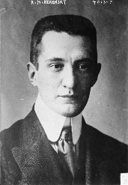
- ____________________________ _____________________________________ (1881-1970): leader of the provisional government
  - Removed _____________________ of the Czar from the government; continued to wage war against Germany (WWI)
  - Member of the _____________________ ___________________________ Party
  - Kerensky would eventually be overthrown by another Marxist group (the ________________________) led by Lenin in 1917
- The _____________________________: a faction of the Russian Social Democratic Party
  - The term “Bolshevik” comes from the Russian word for “majority”….even though the Bolsheviks were ______________ a majority
  - Eventually become known as “_____________________________”
- ______________________________ _________________________ (1870-1924): born into a middle class family; real name is Vladimir Illyich Ulyanov
  - 1897: exiled to ______________ for a failed plot against the Czar; becomes a Marxist
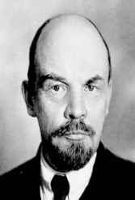
  - Used the name “_____________________” as a code name
  - While in exile in _________________________, learns of the revolt against the Czar
    - Returns to Russia with the help of _____________________.
  - Lenin plans and leads the removal of __________________________ then seizes power as a _________________________________
- Leon _______________________: Lenin’s deputy and head of the Red Army
  - Helped organize the “October Revolution” that brought the _____________________ to power
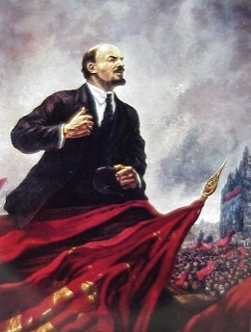
  - Supporter of the Comintern movement (Communism International)
- The ______________________________ _________________________ (AKA The _____________________ ____________________________ or the “______________ ________________________________”)
  - In the Fall of __________, _______________________ overthrow Kerensky in a coup d’état
  - Dictatorial powers are given to Lenin
- The Treaty of the _________________________-___________________________: Lenin orders an end to Russia’s involvement in WWI
  - Sends a delegation, led by _________________________, to sign a peace treaty favorable to the ______________________
  - Treaty will allow Lenin time to consolidate his _________________ in Russia
  - Treaty will permit the Germans to focus and concentrate their forces on the ____________________ ____________________ (with France)
- The Russian Civil War: Between 1918-1920, ____________ _______ breaks out between:
  - The “___________”------ _______________ forces
  - The “_________________” ------- a collection of anti-communist and pro-Czar forces
  - Both the Reds and the Whites committed war crimes during the civil war BUT Lenin (leader of the Reds) took it to the level of ____________________.
    - Lenin ordered the destruction of the Don _____________ people
    - __________________ of the approximately 1 million Cossacks were killed
  - War communism: policy during the Russian Civil War that permits the government to __________ factories and use any _____________________ ____________________ for support of the Red Army.
- The _____________________ (The All-Russia Extraordinary Commission to Combat Counter-Revolution and Sabotage”: the Communist _____________ ______________ force
  - Carried out _______________________ and ran the ___________________ _____________ for Lenin
  - Tortured and executed children as young as 8.

