- The ______________________________ System: feudal method of land ownership and organization
  - Peasant labor: _________________ the labor; main source of income for nobles
- The ________________ _________________________
  - Each estate had specific roles and privileges
  - 1st Estate: the _____________________
  - 2nd Estate: the ___________________
  - 3rd Estate: the ____________________ of society
    - The third estate paid most of the taxes
  - The Estates General: France’s attempt at a ________________________________
- Louis XIV: Reduced the power of the _________________________; fought 4 wars and greatly increased France’s national _________________________; was an absolutist ruler
- The Seven Years War: Louis XV; Fought wars in Europe, India, and North America
  - France ends up losing some of its colonial possessions
  - Increased French national ______________________
  - The Seven Years War is also known as the ________________ and __________________ War
- Influences on the French Revolution:
  - The _____________________________: new ideas about society and government
    - The __________________________ _________________________and the right to revolution
  - American Revolution: France supported the colonists; Revolutionary ideals
  - Financial Crisis: Finance Minister Jacques _______________________
  - Debt from: American Revolution; Seven Years War; All of wars raged by Louis XIV and Louis XV
  - Necker taxed ____________________ which meant the 1st and 2nd Estates had to pay taxes
- The __________________________ ___________________ meet. Each Estate had one vote. Clergy and nobility usually joined together to outvote the Third Estate (May 1789)
  - ________________________ controversy: each delegate a vote? Or each estate gets a vote?
  - The __________________________ ________________________________: the Third Estate established its own government
- Confrontation with Louis XVI who ordered Third Estate locked out of the National Assembly’s meeting hall. Where should the National Assembly meet?
  - The _________________________ ____________________ Oath & King reverses his position; the oath stated they wouldn’t leave France until it had a new constitution.
- Storming the __________________ (a French prison): riots in Paris lead to Finance Minister Necker being fired; July 14th, 1789: storm and take the Bastille
- ____________________ spreads! National Assembly ends feudal privileges
- The ______________________ of the ________________ of ______________ and ______________: outlined basic freedoms held by all (natural rights); “Liberté, Egalité, Fraternité”
- The March of __________________: thousands, starving, protest—force Louis XVI to return to Paris
- National Assembly confiscates and sells off __________________ lands. Clergy must swear an __________ of _______________; secularization of the church
- Louis XVI and family attempt to _____________; arrested at Austrian border
- New ____________________________ (1791): constitutional monarchy; new assembly formed, _________-____________________ (most radical group in Paris)
- Reactions from other countries:
  - Declaration of _________________: Austria/Prussia willing to intervene to save the royal family
  - France declares war on _____________________ (1792-1797); uses a draft
- Radicals take over: Louis XVI arrested and deposed
- The ______________________: thought to be more human method of execution
  - 1000s guillotined during the French Revolution
  - ___________________________ of King Louis XVI: convicted of treason (Jan. 1793)
- _______________________: radical Jacobin; head of the Committee of Public Safety
- Committee of Public Safety: dictatorial power, ruled France for a year
  - To get rid of ______________ and enemies
- The __________________ of ________________: July 1793 - July 1794
  - Committee of Public Safety had power
  - Executions: __________________ people, including Queen Marie-Antoinette (Oct. 1793)
  - Death of ___________________ ends the Reign of Terror
- The _____________________________ Reaction: Robespierre overthrown (Thermidor is the 11th month in the Revolutionary Calendar)
  - Committee of _________________ _______________ dismantled
  - New constitution adopted (1795)
  - Executive branch called the _____________________
- The Directory (executive branch): promoted middle class interests
  - Financial _________________, food ________________, _____________ in Paris
  - Rise of ______________________: intervened to end a ___________________
- Napoleon Bonaparte: 1799 __________ d’état; overthrew the Directory
  - Marks the ______________ of the French Revolution
  - New government called the ____________________
  - 1804: crowns himself ___________________
  - takes over the world: occupies Vienna (Austria), Berlin (Germany), invades Spain, Portugal, and Russia; ______________ holds out; rejects peace deal and Paris falls.
  - Exiled to ______________ island; escapes; resumes power
  - Duke of Wellington (English) defeats Napoleon at the Battle of ______________; imprisoned at _________ _________________________ where he dies
- _______________ of __________________ (1814-1815): Britain, Austria, Russia, Prussia, and France
  - Restored former ________________ Napoleon had unseated back to their thrones
  - Created Netherlands, Germany, Italy
  - Vowed to ______________ future _________________________
  - Kept _____________________ in Europe until ___________________
- Legacies of the French Revolution
  - End of ________________________
  - Power of nobles ended
  - ____________________ became landowners
  - rise of ______________________
  - upheld __________________________ ideals

Louis XIV = ______________ (The Sun King)
Louis XV = ______________
Louis XVI = ______________ (the last king of France)
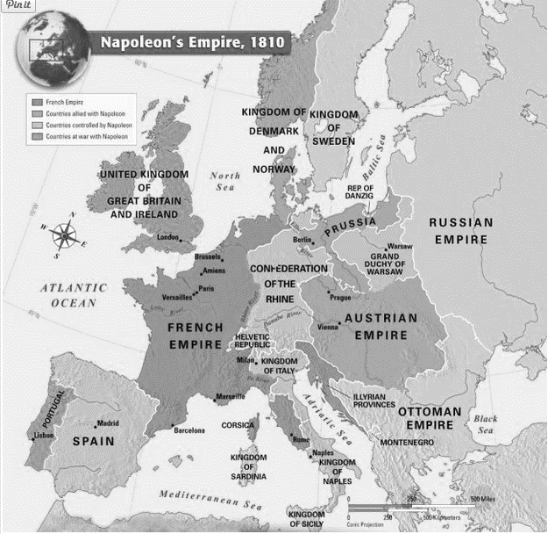
Timeline of the French Revolution
1789 Jun National Assembly established
Jul Storming of the Bastille
Aug Declaration of the Rights of Man and Citizen
Oct March of Women
1791 Jun Louis XVI and family try to flee
Sep New constitution adopted
1792 Apr France declares war on Austria and Prussia
Aug Mob takes Louis XVI and family hostage
Sep Monarchy abolished, Republic of France Declared
1793 Jan Execution of Louis XVI
Apr Committee of Public Safety is created
Sep Reign of Terror begins
Oct Execution of Marie Antoinette
1794 Jul Robespierre executed, Reign of Terror ends; Committee of Public Safety disbanded
1795 Aug New constitution adopted (second constitution)
Oct The Directory becomes the governing body of France
1799 Nov Napoleon’s coup d’état takes over The Directory; marks the end of the French Revolution

