- The world between World War I (WWI) and World War II (WWII)
  - 1919: ________ epidemic. 22 million people die—double the people killed in __________
  - __________________ sky rockets in Germany; need a wheel barrow to buy a loaf of bread!
  - 1925: Locarno Treaty: Germany & France guaranteed _____________ borders to prevent future wars
  - 1930s: _____________________ __________________________
  - Germany lead by the _____________________ ________________ with its weak leadership, economic problems, and Paul von ______________________________ as president
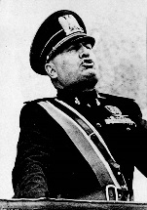
- __________________________________ state: government seeks ____________________ control over political, economic, intellectual, & cultural lives of its people
- ______________________________: glorifies the belief in the 1-party system with a dictator and strong military
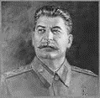
- Italy’s Dictator: Benito _______________________________ (1883-1945): started Italy’s first _________________ party and was liked by the _______________ class who feared socialism and communism
- The Soviet Union AKA The __________________ (or CCCP in Russian)
  - 1924: ______________ dies and a power struggle between Trotsky and __________________ begins
    - _________________ wins; Trotsky is assassinated in exile in Mexico
  - Josef _______________________ (1878-1953): Georgian by nationality; “Stalin” means “man of _______________”. Stalin was VERY brutal & VERY paranoid
- The Soviet Union under Stalin:
  - ______ _________ _____________: economic goals, reviewed every 5 years, to move Russia from an agricultural society to a modern industrialized nation
  - ________________________ : privately owned farms are eliminated & seized; peasants who owned the farms made employees or eliminated; agricultural productivity ____________
  - Stalin’s use of _________________________ as a _______________________: peasants resisted collectivization—they were executed but not fast enough for Stalin
    - Ordered the ____________ _____________ to seal off areas of protest, take all ___________ supplies, and ________________ to death those who opposed him
    - Primary opposition: ________________ -- small land owning peasants in Ukraine
    - ___________________ million died of enforced starvation
  - Stalin’s use of ______________________: in 1930s, Stalin was super paranoid of ‘______________________’ party members, army officers, gov’t officials, ordinary citizens; called them “_______________________ of the ________________________”
    - They were __________________ or _______________________ en masse
    - Killed ________________________ in the “Great Purge”
  - Stalin’s use of ____________________: prison labor camps in Siberia where prisoners were ____________________ to ____________________. About 5 million died
  - In total, Stalin ___________________ about ________ ___________ of his own people.

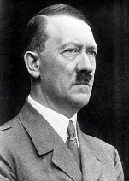
- Germany: the rise of Adolf ___________________ (1889-1945): born in ____________
  - Fought in _____________; wounded at the Somme; 1918: temporarily blinded by mustard gas
  - Army sent him to spy on the National Socialist Workers Party (NSDAP) but he ends up joining
  - 1923: Munich ____________ __________________ ___________________: tried to overthrow gov’t; fails; several Nazis killed; Hitler escapes but is captured and sent to prison
    - While in prison: writes ______________ ______________________ (My Struggle) with his future plans for Germany
  - 1933: Nazis win _____________ seats in the Reichstag (the German Parliament)
  - 1933: Hitler & Hindenburg: power sharing with Hindenburg as President & Hitler chancellor
    - Hitler comes to power initially through the _________________________ process
  - 1933: the ___________________________ Act: Hitler given power to suspend the ________________ for 4 years---in effect, the Reichstag appointed Hitler ________________
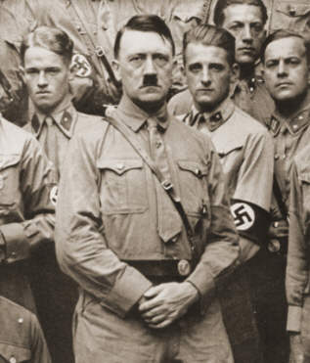
  - 1934: Pres. Hindenburg dies; Hitler takes _____________ _______________ in Germany; is called “___________ ________________” or “The Leader”
- Nazi Germany:
  - The ______________ (or Storm Troopers) AKA the “Brownshirts”—provided security for the Nazi party and beat up political opponents
    - 1934: ___________________ of the ______________ __________________________: by secret agreement between Hitler & the Army, they’d get rid of the SA; SA leader Ernest _____ and other Nazi leaders killed----Hitler assessed Rohm had become a threat to Hitler’s power
  - The ____________: Hitler’s body guards; carried out the Night of the Long Knives
    - Replaced SA as most powerful political military force in Nazi Party
  - The _____________________: state secret police: root out enemies of Nazi state
- Nazi ideology:
  - __________________________________: Living Space: land for German expansion
  - _____________________: mythology that German people were superior to all others and are destined to rule the world
  - ______________-_______________________: anti-Jewish feelings and actions
- Nazi Germany:
  - 1933: began _______________________________ ___________________; the first was Oranienburg (just outside of Berlin)—originally prison camps for political enemies
    - Modeled after Soviet camps which were modeled after British camps during Boer War
  - 1936: _____________________ ________: stripped German ____ of basic rights & citizenship
    - Jews could NOT marry or have sexual relations with a German, took away German citizenship, cannot employ Germans in their homes
    - Jews defined: someone with 3 or 4 grandparents who were Jewish (regardless if person identified ethnically or religiously as Jewish) changes later to 1 grandparent
  - 1938: ____________________________ (“Night of the Broken Glass”): Nazis, Hitler Youth, & police attack Jewish business & synagogues; 7,000 Jewish shows destroyed & 100 Jews killed
    - ________________ Jews rounded up and sent to ___________________________
- Nazi Germany moves toward war
  - 1936: ______________________________ is demilitarized zone between France and Germany; Hitler orders reoccupation; Britain & France do __________________ even though Treaty of Versailles forbids its military occupation
  - _________________________: policy that if European states satisfy Hitler’s ‘reasonable’ demands, war will be avoided—British PM Neville _____________________________ fights for this (it fails miserably)
  - 1936: Hitler and ______________________ sign military alliance (Rome-Berlin Axis)
  - 1938: Germany and _________________ sign (Anti-Comintern Pact to fight communism)
  - 1938 Germany _______________ _________________ (the ________________________)
  - 1938: Hitler demands __________________________ be reunited with Germany; France and Britain give into demands and the Czechs are left defenseless
  - ___________________: city given to Poland after WWI; cuts Germany in two; Hitler demanded it be returned—Britain promised to protect Poland’s claim to Danzig
  - 1939: ________-_______________ ____________ between Germany & Soviet Union: Hitler promises Stalin the eastern part of Poland if Stalin does not oppose Germany’s invasion; AKA the Molotov-Ribbentrop Pact
- _______________ moves toward war
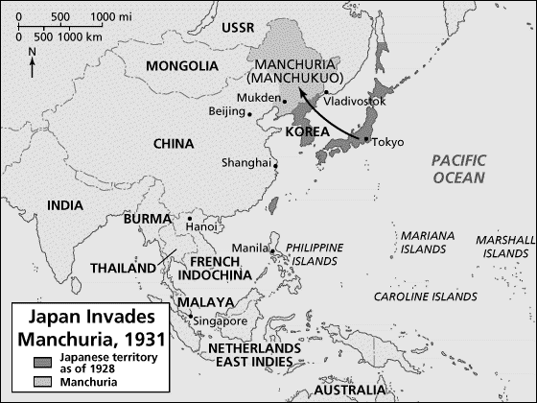
  - 1931: Japan invades _______________________ in China and establishes a puppet state that stays in power until the end of _________________; Japan seized it for natural resources it needed for military production
  - Chinese General ______________ ____________-__________________: leader of nationalist China who was fighting Chinese communists; the Japanese invasion forced him to join with the communists to fight the Japanese
  - 1937: Japan and China in a full scale war
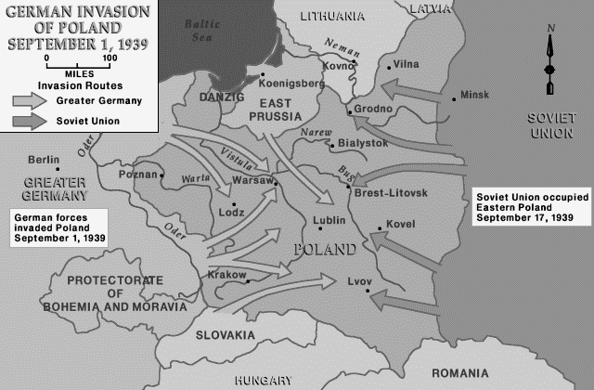
- 9-1-39: _____________________ invades ___________________
  - 9-3-39: Britain declares war on Germany
- ___________________________ (“Lightning War”): Germans used panzer ____________ supported by aircraft and artillery for a _____________ surprise attack
  - By 9-28-39, Germany & Soviet Union divided Poland in half
- 5-10-40: Hitler attacks _____________________, _______________, & ______________________ by going around the _______________ __________ (the French defensive line) & surprises British/ French troops—338,000 British soldiers had to be evacuated from _________________’s beaches
- 6-22-40: Germany signs an ________________________ with France. Germany occupies __________ of France; occupied region has a government controlled by _________________ called _______________________
- The US and President Franklin D. Roosevelt (FDR) remain ____________ and have a policy of ________________________
- Battle of ___________________ is an ________________ battle between the Royal Air Force (Britain) and the _________________ (German Air Force); in Aug 1940: Germans launch major attack on British cities and land
- Operation ___________________________: code name for German invasion of _________________
  - Hitler didn’t want to fight _____ _________ war; thought USSR would eventually help British
  - 6-22-41: Germany invades the USSR but German forces stopped because of early winter and strong Soviet resistance; by Dec. 1941: Soviets counterattack ______________ the invasion
- By ____________, Japan controlled most of southeast Asia and the West Pacific
- __________ ______, ___________: Japanese attack ____________________ _________________ (the US Pacific Fleet’s home base) killing 2,402 Americans; The United States ______________ ________ and _________________ declares war on the U.S.
- German General Erwin ______________ (The “Desert Fox”): sent to North Africa to rescues the Italians; lead the German troops in _________________ __________________; Summer 1942: British troops stop Germans at ___ _______________; Nov 1943: German/Italian surrender in North Africa
- Hitler wanted to defeat the Soviets at ________________________ because he hated Stalin
  - Nov 1942-Feb 1943: Soviets counterattacked, cut off supply lines in middle of winter
  - German forced to surrender----first ___________ _____________ of the Nazis in Europe
- In the _____________________ Theater: Battle of ______________________ (June 1942): turning point of Asian Theater; U.S. planes destroy 4 Japanese aircraft carriers Japan used at Pearl Harbor
- _________-____________: June 6, 1944: The Allied invasion of Europe (Operation ______________)
  - Commander: General “Ike” _________________________________
  - Allied forces land on the beaches of ___________________________, France
  - Within 2 months, 2 million Allied troops, 500,000 vehicles had landed
- ______________: Fall of ____________________: Germany caught between U.S./British/Allied troops advancing from the West and the Soviets advancing from the East; May 1945: Berlin falls to the Soviets; ___________ kills himself
- War with Japan: the _________________ ________________
  - FDR died; President now _____________—must decide to use or not to use the atomic bomb
    - Developed under the ___________________________ Project
  - ___________ ___________, 1945: ___________________________
  - ___________ ___________, 1945: ___________________________
  - Aug 14, 1945: Japan surrenders
- WWII officially over with 60 million dead.

