- The M.A.I.N. causes of World War I (WWI):
  - M – _________________________; glorification of military service
    - To be a great nation, you must have a ______________________ military
  - A – _________________________; 1882, Germany starts making alliances that become the _____________________ _________________ during WWI (Germany, Austria, Italy)
  - I – __________________________
  - N - __________________________; deep devotion to one’s country
    - The ___________________ (The “Powder Keg of Europe”): broke away from the Ottoman Empire into Serbia, Greece, Bulgaria, & Romania
      - Slavic people argued ______________ for the ___________
      - Austria-Hungary didn’t want to give up Bosnia & Herzegovina
- June 28, __________ : Archduke Francis ________________________ & wife, heirs to the Hapsburg throne of the Austria-Hungary Empire, assassinated by Gavrilo _______________ while in Sarajevo
  - The ______________ ________________ AKA “Union of Death”: Serbian terrorist organization of anarchists & revolutionaries. Goal was to create chaos in _________________
  - The assassination aftermath: Kaiser Wilhelm II of _________________, an ally of Austria-Hungary, authorizes Austria-Hungary to avenge Ferdinand & wife’s deaths
  - Austria-Hungary _____________________ to Serbia: allow military forces to ____________ planners of the assassination or _____________
- Some of the WWI Alliances
_________________ Powers | _________________ Powers
Serbia
 | Germany
England
 | Bulgaria
- The _______________________ Plan (1905): German plan of how to fight future war with France.
  - Avoid two ____________ (like fighting France and Russia at the same time)
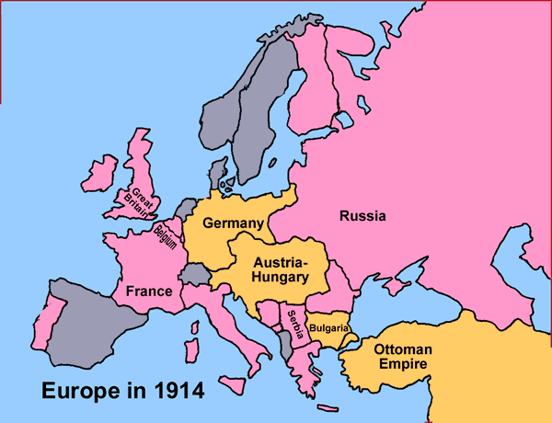
  - Assumed that: France would fall quickly, _________________ would stay neutral, Russia would be ______________ to respond, & Austria could easily beat ________________
  - Plan in action: 5 German armies attack through neutral ___________________ with a goal of conquering ____________; 2 German armies would contain the Franco-German border
    - Plan doesn’t work! Assumptions weren’t accurate; ____________ declare war, French actually fight, Russians move ____________
- The war brings a FLOOD of ___________________________ (ideas spread to influence people to support or go against a cause). WWI used newspapers, postcards, posters, silent movies
- FIRST Battle of the ____________: Allied _____________; stopped German advance just NW of Paris
- _____________ built on the Western Front
- Use of __________________ weapons
  - 1st use: Battle of ____________ (1915) by the Germans
  - _________________ _________: blistered and burned the skin and lungs
- Battle of ___________________ (1915): naval operation to defeat Turkey and open supply route to _____________. Stalemate/failure for the ________________; heavy losses in men & battleships
- The Germans announce they will attack any _____________ without ANY _______________ if the Germans think the ship is helping the Allies. Use of submarines (____ - _____________)
  - Germans sink the _____________________ in May 1915; the ship is a British passenger liner that results in 1,119 deaths, including 114 Americans. Fuels anti-___________ feelings
- Battle of ________________ (Feb – Dec 1916): approximately 700,000 men killed or wounded; considered a _______________ victory because they “held on”; famous French slogan: “They shall not pass!”
- Battle of the ______________ (1916): only large scale naval surface battle; is a draw
- Battle of the ______________ (Jul-Nov 1916): fought in France with mostly British troops
  - Opening day: British lost 60,000 men
  - War of ___________________: idea that you can win a war by “bleeding” your enemy to death over time; ____________ victory because it “wore down” the Germans
  - Adolf ________________ was a German soldier wounded during the Battle of the Somme
- American President _________________ _______________: re-elected in 1916 because he “kept us out of the war”---
  - Jan 1917:_______________________ __________________: sent from German Foreign Minister Zimmerman to Minister in Mexico offering Mexico ______ __________ in exchange for alliance in WWI
  - declares war on German in April ____________
  - The stated reason for declaring war: Germany’s continued sinking of ships with its U-Boats
- WWI becomes a ____________ _______ (complete mobilization of resources and people, affects the lives of all citizens, even those not near a battlefield
- Second Battle of the _________________ (Jul 1918): German offensive stopped by ____________/________
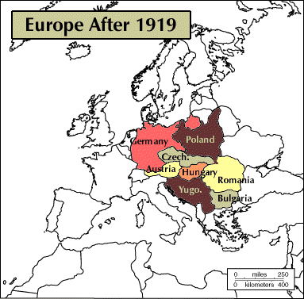
  - Heavy use of _____________________
- ____________________________!! Nov 11, 1918: stop to the fighting
- Effects of WWI
  - Germany crushes a communist revolution
  - ______________-______________ split into Austria, Hungary, Czechoslovakia, & Yugoslavia
  - 10 million dead
- ______________ Peace Conference:
  - Wilson’s _______ __________: calls for a League of Nations; U.S. Senate doesn’t ratify so the U.S. never joins it
  - British Prime Minister David Lloyd George: __________________ Germany for the war
  - French Premier George Clemenceau: Germany must _______ _________ of war, be demilitarized, and have a buffer zone with France
  - German & Russia didn’t attend---not a negotiation with Germany
- Treaty of _________________________ (June 28, 1919)
  - “The ___________ _______________ Clause”: Germany must accept FULL BLAME and responsibility for the war
    - Germany must pay ALL ___________ of the war: 22 BILLION to the allies; finished payments in _____________
  - Germany’s _____________ limited to 100,000 men; air force dismantled, and navy restricted in size; All _________________ must be destroyed
- Effects of the Ottoman Empire defeat: _______________ & _______________ given “mandates” to control Middle East regions until more permanent solution found; considered territories not colonies
- In Germany, the loss suffered in WWI was explained as a “__________________________________________” by disloyal Jews. This explanation would influence German decisions made during World War II.

