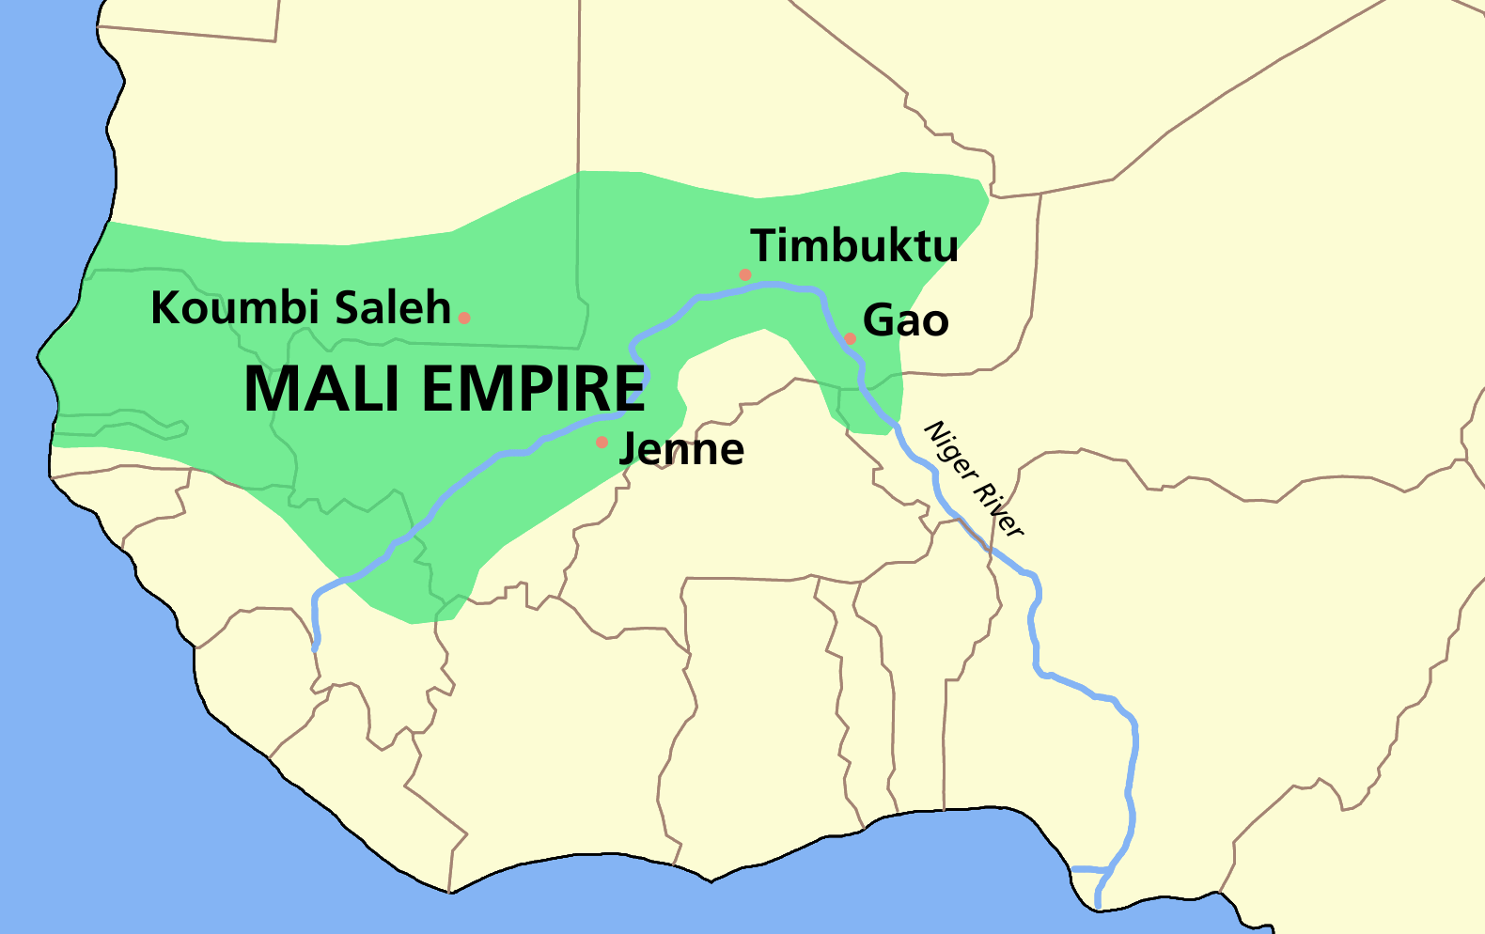
- Who may have been the richest person in history? Possibly Musa Keita I who ruled the _______________ Empire in the 14th Century.
  - Musa Keita I was also known as _______________ Musa.
- Mansa Musa came to power in _____________.
- He annexed the city of _____________________________, (he added it to his kingdom), established influence over Gao, and controlled trade routes—this dramatically increased Mali’s size.
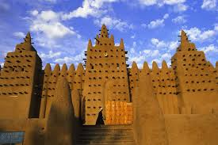
- In 1324, Mansa Musa took a pilgrimage to ______________________. This was the first time the world observed his vast wealth.
  - His journey took over a _________________.
- Mansa Musa was a devout ___________________.
  - He made the city of Timbuktu a center of Islamic learning.
    - He had the Djingareyber Mosque built.
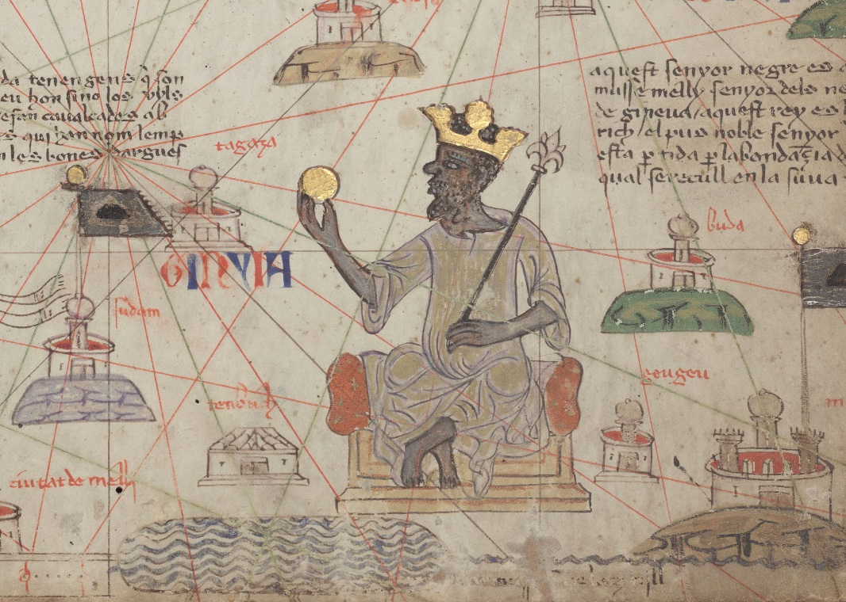
    - 1He had a ______________________ built in Timbuktu to emphasize learning and attract Islamic scholars from all over the world.

