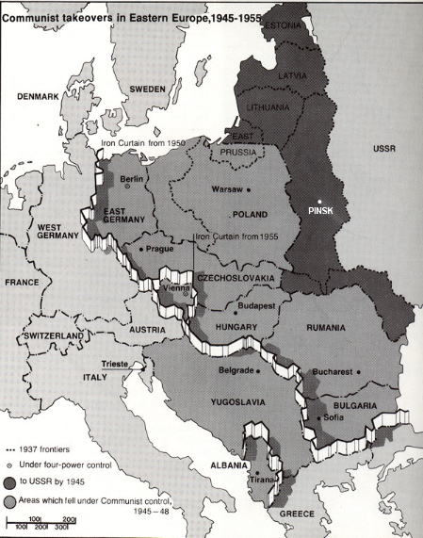
- The __________________ ____________ (1946-1992): period of tension between the democracies in the West and the communist countries of Eastern Europe.
  - Never officially declare _____________ on each other…hence it is called a “________” war
- The Iron Curtain: __________________________________
_________________________________________________
_________________________________________________

- The Truman Doctrine: ______________________________
_________________________________________________
_________________________________________________
- Containment: _______________________________________________________________
___________________________________________________________________________
- The Marshall Plan: ___________________________________________________________
___________________________________________________________________________
- _______________ ______________: Soviet dominated nations of Eastern Europe that provided a _________________ for the USSR
  - These states refused to participate in the _______________ _____________ because they believed the U.S. was trying to ‘buy out communism’
- _______________________ _____________: believed that if one country in a region came under the influence of communism, then the surrounding countries would follow in a domino effect.
- Post WWII: Germany was divided into __________ sections. Each section occupied by the _______, ____________________, ____________________, or ________________
  - ___________ Germany = ________________ (GDR)
  - ___________ Germany = _____________________ (FRG)
  - Berlin, which was inside the ___________ zone, was divided into ______ sections
    - 1948-1949: Soviets cut off all supply routes into the city; U.S. & allies resupplied Berlin by __________ (called the _______________ __________)
- ________________: The North Atlantic Treaty Organization: all members promised to help each other if attacked (by the _________________); countries included the __________, Belgium, France, West Germany, Turkey, Greece, Italy, etc.)
- The Warsaw Pact: ____________________________________________________________
___________________________________________________________________________
- 1950: Korean War: ___________________________________________________________
___________________________________________________________________________
- Space Race: ___________________: 1st man-man satellite in space, launched by the ______ in 1957; U.S. feared it was losing the “space race”
- 1962: ____________________ _________________ ________________: Soviets began installing nuclear missiles in ________________, aimed at the __________
  - President Kennedy: ____________ blockade on Cuba
  - Soviets withdrew missiles after U.S. agreed to remove similar missiles in __________
- 1965-1975: Vietnam War: _____________________________________________________
___________________________________________________________________________
- Berlin Wall: _________________________________________________________________
___________________________________________________________________________
___________________________________________________________________________
  - “Mr. Gorbachev, tear down this wall!” – U.S. President __________ (1987)
  - ______________: Berlin Wall is torn down
- Fall of the Soviet Union: _______________________________________________________
___________________________________________________________________________
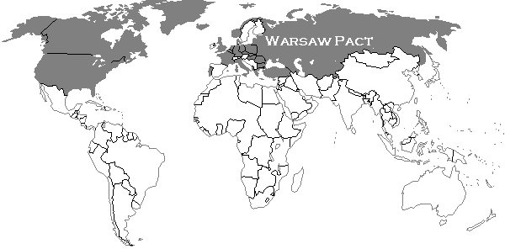
___________________________________________________________________________

NATO Countries:
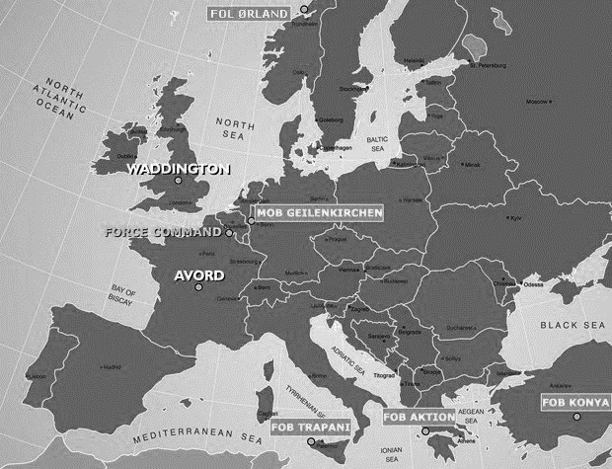

Warsaw Pact Countries:

