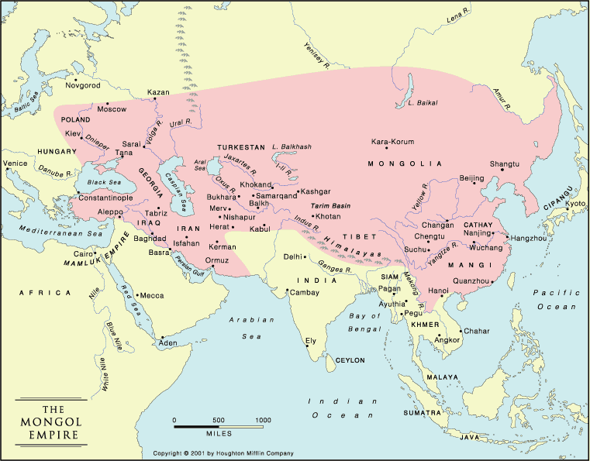
- In _________, the Prophet Muhammad dies.
  - ________________ has spread throughout the Middle East
- By 1215, __________________ from eastern Asia had invaded and took over most of the Middle East
  - Islam’s power started to ___________________.
- Creation of the _______________________ Empire:
  - Sultan _______________ of Anatolia (Turkey) expands and founds the Ottoman Empire, starting in ___________ until __________.
- Quick Facts:
  - One of the _____________ and longest lasting empires in history
  - Supported and inspired by ___________________
    - Founded on the principles of Islam
    - Churches converted to __________________
    - Tolerant of other ______________________, especially Christians and Jews
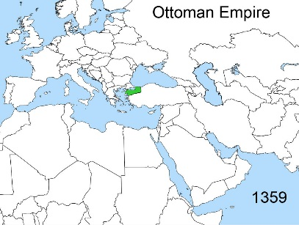
  - Replaced the _____________________ Empire as the major power in the Eastern Mediterranean
- The Janissaries
  - _______________ loyal to the ________________
  - An army of slaves and Christians that converted to ____________________
    - An elite group of soldiers
  - Helped to expand the empire
  - Become SO powerful, sultans sometimes feared them
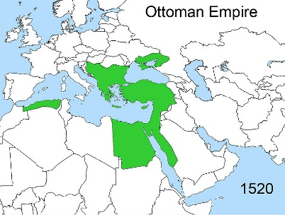
- Expansion of the Ottoman Empire:
  - _________ sultans crossed into Europe
  - _________ Janissaries conquered _____________________ (Istanbul) and defeated the Byzantine Empire
  - _________ extends to Egypt and North African coast
  - _________ - _________: Peak of Empire’s power under Suleiman
- __________________ “the Magnificent” (reigned from 1520-1566)
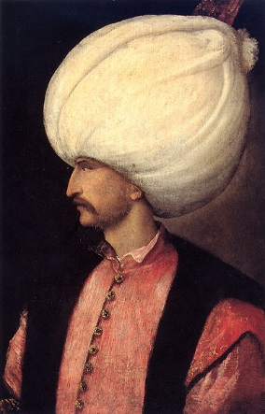
  - Made the empire the ____________ and most ________________ empire in Europe and southwest Asia
  - Known as the ______________
    - Code of ___________
    - Reformed the government
  - Made Constantinople (Istanbul) the center of : _____________, music, _____________, and philosophy; was a _________________
  - Entire world his possession (a gift from God)
    - Invaded, conquered, or annexed
    - VERY strong ________________
  - Expert in developing _________________________ as military tool
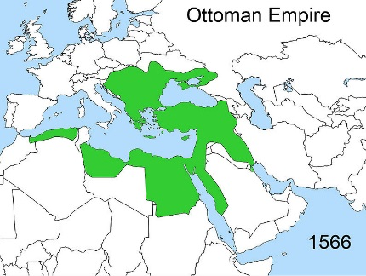
  - Doubled the size of the empire in ______ campaigns
  - Killed ________ sons and __________________ to protect the throne for his heir
  - Died on campaign in Hungary
- ___________________________ of other religions
  - Allowed people to ________________ to Islam
  - Constantinople (Istanbul) became a ________________ for ____________ who were be oppressed in Europe.
  - ___________________ System:
    - Non-Muslims could form small communities of ______________
    - Can practice their faith if they pay a _______________
    - Legal systems of communities: faith-based
- ___________________ of the Ottoman Empire:
  - 1571: several military defeats
  - 1683: failed ______________ of Vienna, Austria
  - Economic problems:
    - Trade competition from the ____________________
    - Cheap products from India and the Far East
    - Rising ________________________
    - Rising bankruptcy
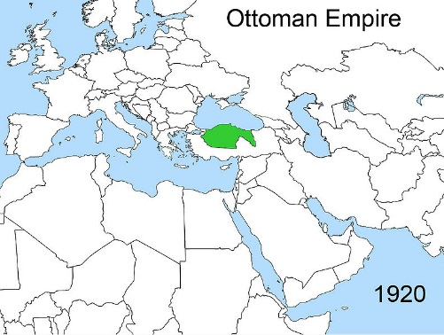
    - Weak leaders
    - These _____________ problems weakened the __________________
  - Lost _________ _______ ____ (fought on the German side)
    - Lost control of Arab lands
  - Officially ended Nov 1, _____________
    - _________________ was declared a republic

